**Materi Praktikum Bootstrap 5**

Persiapan file-file bootstrap 5.1.3, fontawesome 6.2.0, kode program php

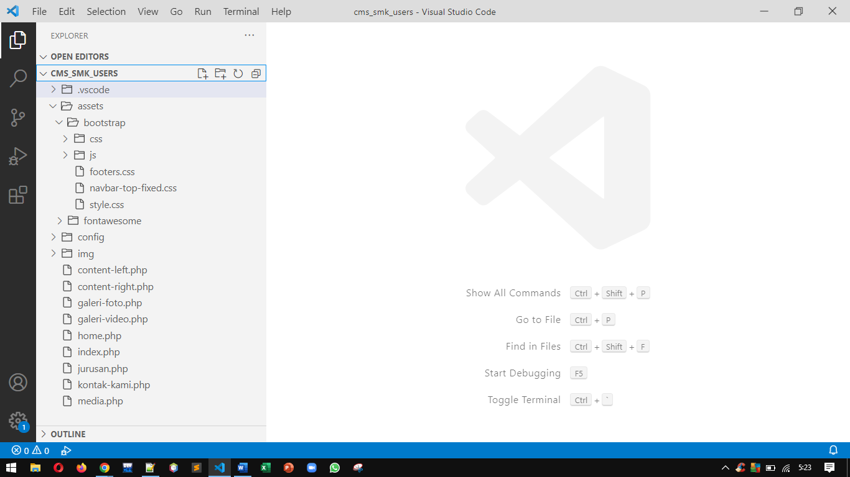

Gambar 1. Persiapan file-file

Kode program index.php

|  |
| --- |
| <?php  **header**("location:media.php?page=home");  ?> |

Kode program media.php

|  |  |
| --- | --- |
| <?php  //include "config/koneksi.php";  ?>  <!doctype html>  <html lang=**"en"**>  <head>  <!-- The above 3 meta tags *must* come first in the head; any other head content must  come*after* these tags -->  <meta charset=**"utf-8"**>  <meta name=**"viewport"** content=**"width=device-width, initial-scale=1"**>  <meta name=**"description"** content=**""**>  <meta name=**"author"** content=**"Mark Otto, Jacob Thornton, and Bootstrap contributors"**>  <meta name=**"generator"** content=**"Hugo 0.88.1"**>  <!-- Title this website -->  <title>**SMK Islamiyah**</title>  <!-- Documentation about album bootstrap v5.1 -->  <link rel=**"canonical"** href=**"https://getbootstrap.com/docs/5.1/examples/navbar-fixed/"**>  <!-- Bootstrap core CSS -->  <!-- Bootstrap version 5.1.3 -->  <link rel=**"stylesheet"** href=**"assets/bootstrap/css/bootstrap.min.css"**>  <!-- Custom template bootstrap -->  <link rel=**"stylesheet"** href=**"assets/bootstrap/navbar-top-fixed.css"**>  <link rel=**"stylesheet"** href=**"assets/bootstrap/footers.css"**>  <!-- Icons core CSS -->  <!-- Font-Awesome version 6.2.0 -->  <link rel=**"stylesheet"** href=**"assets/fontawesome/css/fontawesome.min.css"**>  <link rel=**"stylesheet"** href=**"assets/fontawesome/css/brands.min.css"**>  <link rel=**"stylesheet"** href=**"assets/fontawesome/css/solid.min.css"**>  <!-- Style for page index -->  <style>  **p {**  **text-align: justify;**  **}**  **.bd-placeholder-img {**  **font-size: 1.125rem;**  **text-anchor: middle;**  **-webkit-user-select: none;**  **-moz-user-select: none;**  **user-select: none;**  **}**  **@media (min-width: 768px) {**  **.bd-placeholder-img-lg {**  **font-size: 3.5rem;**  **}**  **}**  </style>  </head>  <body>  <!-- --------------------------------------------------------- -->  <!-- header and navbar --------------------------------------- -->  <!-- --------------------------------------------------------- -->  <header>  <nav class=**"navbar navbar-expand-md navbar-dark bg-dark bg-gradient fixed-top"**>  <div class=**"container"**>  <a class=**"navbar-brand"** href=**"?page=home"**>**SMK Islamiyah Ciputat**</a>  <button class=**"navbar-toggler"** type=**"button"** data-bs-toggle=**"collapse"**  data-bs-target=**"#navbarCollapse"** aria-controls=**"navbarCollapse"**  aria-expanded=**"false"** aria-label=**"Toggle navigation"**>  <span class=**"navbar-toggler-icon"**></span>  </button>  <div class=**"collapse navbar-collapse"** id=**"navbarCollapse"**>  <ul class=**"navbar-nav ms-auto mb-auto mb-md-auto"**>  <li class=**"nav-item"**>  <a class=**"nav-link"** href=**"?page=home"**>  <i class=**"fa-solid fa-house-user"**></i> **Home**  </a>  </li>  <li class=**"nav-item"**>  <a class=**"nav-link"** href=**"?page=profil"**>  <i class=**"fa-solid fa-book"**></i> **Profil**  </a>  </li>  <li class=**"nav-item"**>  <a class=**"nav-link"** href=**"?page=jurusan"**>  <i class=**" fa-solid fa-graduation-cap"**></i> **Jurusan**  </a>  </li>  <li class=**"nav-item"**>  <a class=**"nav-link"** href=**"?page=galeri-foto"**>  <i class=**"fa-solid fa-camera"**></i> **Galeri Foto**  </a>  </li>  <li class=**"nav-item"**>  <a class=**"nav-link"** href=**"?page=galeri-video"**>  <i class=**"fa-solid fa-video"**></i> **Galeri Video**  </a>  </li>  <li class=**"nav-item"**>  <a class=**"nav-link"** href=**"?page=kontak-kami"**>  <i class=**"fa-solid fa-envelope"**></i> **Kontak Kami**  </a>  </li>  <!-- /. menu-list -->  </ul>  <!-- /. navbar-list -->  </div>  <!-- /. navbar-collapse -->  </div>  <!-- /. container -->  </nav>  <!-- /. navbar -->  </header>  <!-- --------------------------------------------------------- -->  <!-- /. header and navbar ------------------------------------ -->  <!-- --------------------------------------------------------- -->  <!-- --------------------------------------------------------- -->  <!-- . main content ------------------------------------------ -->  <!-- --------------------------------------------------------- -->  <main class=**"container"**>  <!-- row content-->  <div class=**"row mb-3"**>  <div class=**"col-md-8"**>  <?php **include** "content-left.php"; ?>  </div>  <!-- /.col content-left -->  <div class=**"col-md-4"**>  <?php **include** "content-right.php"; ?>  </div>  <!-- /.col content-right -->  </div>  <!-- /.row content-->  <!-- footer-->  <footer class=**"py-2 my-2 text-muted border-top"**>  <p class=**""**>**Copyright all rights reserved 2022 by Aryajaya Alamsyah**</p>  </footer>  <!-- /.footer-->  </main>  <!-- --------------------------------------------------------- -->  <!-- . main content ------------------------------------------ -->  <!-- --------------------------------------------------------- -->  <!-- Javascript for custom template boostrap 5 -->  <script src=**"assets/bootstrap/js/bootstrap.bundle.min.js"**></script>  <!-- Javascript for custom fontawesome 6.2.0 -->  <script src=**"assets/fontawesome/js/fontawesome.min.js"**></script>  <script src=**"assets/fontawesome/js/brands.min.js"**></script>  <script src=**"assets/fontawesome/js/solid.min.js"**></script>  </body>  </html> |  |

Kode program content-left.php

|  |
| --- |
| <?php  **if** ($_GET["page"] == "home") {  **include** "home.php";  } **else** **if** ($_GET["page"] == "jurusan") {  **include** "jurusan.php";  } **else** **if** ($_GET["page"] == "galeri-foto") {  **include** "galeri-foto.php";  } **else** **if** ($_GET["page"] == "galeri-video") {  **include** "galeri-video.php";  } **else** **if** ($_GET["page"] == "kontak-kami") {  **include** "kontak-kami.php";  } **else** {  **echo** "<p>Modul tidak ada. Masih dalam pengerjaan.</p>";  }  ?> |

Kode program content-right.php

|  |
| --- |
| <!-- Sosial Media -->  <div class=**"alert alert-danger rounded"**>  <p class=**"fs-5"**><i class=**"fa-solid fa-envelope"**></i> **Sosial Media**</p>  <button type=**"button"** class=**"btn btn-md btn-outline-danger mb-2"**>  <i class=**"fab fa-facebook"**></i>  </button>  <button type=**"button"** class=**"btn btn-md btn-outline-danger mb-2"**>  <i class=**"fab fa-twitter"**></i>  </button>  <button type=**"button"** class=**"btn btn-md btn-outline-danger mb-2"**>  <i class=**"fab fa-instagram"**></i>  </button>  <button type=**"button"** class=**"btn btn-md btn-outline-danger mb-2"**>  <i class=**"fab fa-youtube"**></i>  </button>  <button type=**"button"** class=**"btn btn-md btn-outline-danger mb-2"**>  <i class=**"fab fa-whatsapp"**></i>  </button>  </div>  <!-- Tanggal Penting -->  <div class=**"alert alert-danger rounded"**>  <p class=**"fs-5"**><i class=**"fa-solid fa-calendar-days"**></i> **Tanggal Penting**</p>  <ul>  <li>**25 Juli - MPLS Sekolah**</li>  <li>**17 Agustus - Kemerdekaan RI**</li>  <li>**18 September - PTS Ganjil**</li>  <li>**28 Oktober - Sumpah Pemuda**</li>  </ul>  </div>  <!-- Ekstrakurikuler -->  <div class=**"alert alert-danger rounded"**>  <p class=**"fs-5"**><i class=**"fa-solid fa-book"**></i> **Ekstrakurikuler**</p>  <ul>  <li>**Pramuka**</li>  <li>**Paskribaka**</li>  <li>**Basket**</li>  <li>**Volly**</li>  </ul>  </div>  <!-- Kerjasama Industri -->  <div class=**"alert alert-danger rounded"**>  <p class=**"fs-5"**><i class=**"fa-solid fa-handshake-simple"**></i> **Kerjasama Industri**</p>  <ul>  <li>**UIN Syarif Hidayatullah Jakarta**</li>  <li>**PT. Telkom Jakarta**</li>  <li>**PT. Jaya Real Property**</li>  <li>**PT. Hero Supermarket Jakarta**</li>  </ul>  </div> |

Kode program home.php

|  |
| --- |
| <!-- --------------------------------------------------------- -->  <!-- . Sejarah SMK ------------------------------------------- -->  <!-- --------------------------------------------------------- -->  <article class=**"blog-post"**>  <h2 class=**"blog-post-title"**>**Sejarah SMK Islamiyah Ciputat**</h2><hr>  <p class=**"blog-post-meta"**>**Didirikan pada tahun 1965 oleh Drs. H. Zarkazih Noer yang**  **mempelopori pembangunan Yayasan Islamiyah Ciputat ini. Awalnya proses kegiatan**  **belajar mengajar terpaksa dilakukan di gedung sekolah swasta lain karena yayasan belum**  **mempunyai gedung sendiri. Namun kini Yayasan Islamiyah Ciputat telah memiliki gedung**  **sendiri.**</p>  <p class=**"blog-post-meta"**>**Mengedepankan pendidikan berorientasi pada prinsip-prinsip**  **islam yang bernaungan IPTEK** & **IMTAQ merupakan visi dari yayasan ini dalam mendidik dan**  **membimbing anak didiknya agar menjadi insan-insan muda yang berkualitas, berprestasi**  **serta berakhlak baik. Terlebih lagi dengan adanya dukungan i-Skola layanan info**  **penting kepada Orangtua/ Wali murid. Diharapkan lulusan yayasan ini selain memiliki**  **wawasan IPTEK yang luas juga memahami, mendalami dan menguasai kaidah serta ajaran**  **Islam yang telah ditanamkan kepada mereka selama mengenyam bangku pendidikan di**  **Yayasan Islamiyah Ciputat. Kedua hal tersebut dirasa bisa menjadi bekal bagi masa**  **depan mereka**</p>  <p class=**"blog-post-meta"**>**Beberapa kegiatan ekstrakurikuler seperti paskibra, marawis**  **atau futsal menjadi sarana bagi anak didik yayasan Islamiyah untuk menyalurkan minat,**  **bakat dan kreatifitas mereka. Salah satu prestasi yang bisa dibanggakan dari yayasan**  **ini yaitu Pasukan Pengibar Bendera Pusaka (PASKIBRAKA) SMA Islamiyah Ciputat pernah**  **mewakili kabupaten Tangerang di tingkat nasional.**</p>  </article>  <!-- --------------------------------------------------------- -->  <!-- /.Sejarah SMK ------------------------------------------- -->  <!-- --------------------------------------------------------- -->  <!-- --------------------------------------------------------- -->  <!-- Visi dan Misi ------------------------------------------- -->  <!-- --------------------------------------------------------- -->  <article class=**"blog-post"**>  <!-- Visi -->  <h3 class=**"blog-post-title"**>**Visi dan Misi Satuan Pendidik**</h3><hr>  <p class=**"blog-post-meta"**>**Membangun Sumber Daya Manusia (Sdm) Yang Berkualitas, Terampil,**  **dan Mampu Bersaing Pada Mampu Bersaing Pada Tingkat Nasional Maupun Global Dilandasi**  **Iman Dan Taqwa Sesuai Ajaran Ahlusunnah Waljamaah.**</p>  <p>**1. Membina Dan Membimbing Peserta Didik Untuk Memiliki Dan Mengamankan Ajaran Islam**  **Serta Berakhlak Mulia Sesuai Dengan Ajaran Ahlusunnah Waljamaah**</p>  <p>**2. Membentuk Peserta Didik Untuk Memiliki Jiwa Kewirausaahan**</p>  <p>**3. Membina Peserta Didik Yang Siap Menjadi Tenaga Kerja Yang Profesional Dan Amanah**  **Dalam Bidang Teknologi Informasi Dan Bisnis Manajemen**</p>  <p>**4. Membina Peserta Didik Yang Siap Menjadi Tenaga Kerja Yang Profesional Dan Amanah**  **Dalam Bidang Teknologi Informasi Dan Bisnis Manajemen**</p>  </article>  <!-- --------------------------------------------------------- -->  <!-- /.Visi dan Misi ----------------------------------------- -->  <!-- --------------------------------------------------------- --> |

Kode program jurusan.php

|  |
| --- |
| <!-- Teknik Komputer Jaringan -->  <div class=**"card mb-3"**>  <div class=**"card-header"**>  <h5 class=**"card-titles"**>  <p class=**"card-text"**>**Teknik Komputer Jaringan**</p>  </h5>  </div>  <div class=**"card-body"**>  <p class=**"card-text"**>  **Lorem ipsum dolor sit amet consectetur adipisicing elit. Quasi cupiditate magnam**  **sapiente beatae hic odio quo corporis! Exercitationem, quod? Quod voluptate**  **suscipit tenetur explicabo nostrum modi ipsam, ea fuga unde .....**</p>  </div>  </div>  <!-- /. card -->  <!-- Multimedia -->  <div class=**"card mb-3"**>  <div class=**"card-header"**>  <h5 class=**"card-titles"**>  <p class=**"card-text"**>**Multimedia**</p>  </h5>  </div>  <div class=**"card-body"**>  <p class=**"card-text"**>  **Lorem ipsum dolor sit amet consectetur adipisicing elit. Quasi cupiditate magnam**  **sapiente beatae hic odio quo corporis! Exercitationem, quod? Quod voluptate**  **suscipit tenetur explicabo nostrum modi ipsam, ea fuga unde .....**</p>  </div>  </div>  <!-- /. card -->  <!-- Akutansi dan Keuangan -->  <div class=**"card mb-3"**>  <div class=**"card-header"**>  <h5 class=**"card-titles"**>  <p class=**"card-text"**>**Akutansi dan Keuangan**</p>  </h5>  </div>  <div class=**"card-body"**>  <p class=**"card-text"**>  **Lorem ipsum dolor sit amet consectetur adipisicing elit. Quasi cupiditate magnam**  **sapiente beatae hic odio quo corporis! Exercitationem, quod? Quod voluptate**  **suscipit tenetur explicabo nostrum modi ipsam, ea fuga unde .....**</p>  </div>  </div>  <!-- /. card -->  <!-- Bisnis Daring dan Pemasaran -->  <div class=**"card mb-3"**>  <div class=**"card-header"**>  <h5 class=**"card-titles"**>  <p class=**"card-text"**>**Bisnis Daring dan Pemasaran**</p>  </h5>  </div>  <div class=**"card-body"**>  <p class=**"card-text"**>  **Lorem ipsum dolor sit amet consectetur adipisicing elit. Quasi cupiditate magnam**  **sapiente beatae hic odio quo corporis! Exercitationem, quod? Quod voluptate**  **suscipit tenetur explicabo nostrum modi ipsam, ea fuga unde .....**</p>  </div>  </div>  <!-- /. card -->  <!-- Tata Boga -->  <div class=**"card mb-3"**>  <div class=**"card-header"**>  <h5 class=**"card-titles"**>  <p class=**"card-text"**>**Tata Boga**</p>  </h5>  </div>  <div class=**"card-body"**>  <p class=**"card-text"**>  **Lorem ipsum dolor sit amet consectetur adipisicing elit. Quasi cupiditate magnam**  **sapiente beatae hic odio quo corporis! Exercitationem, quod? Quod voluptate**  **suscipit tenetur explicabo nostrum modi ipsam, ea fuga unde .....**</p>  </div>  </div>  <!-- /. card --> |

Kode program galeri-foto.php

|  |
| --- |
| <!-- .card-group -->  <div class=**"row row-cols-1 row-cols-md-2 g-3"**>  <!-- Ruang Guru -->  <div class=**"col"**>  <div class=**"card"**>  <div class=**"card-header"**>  <p class=**"card-text"**>**Ruang Guru**</p>  </div>  <!-- /. card-header -->  <div class=**"card-body"**>  <svg class=**"bd-placeholder-img card-img-top"** width=**"100%"** height=**"225"**  xmlns=**"http://www.w3.org/2000/svg"** role=**"img"** aria-label=**"Placeholder: Thumbnail"**  preserveAspectRatio=**"xMidYMid slice"** focusable=**"false"**>  <title>**Placeholder**</title>  <rect width="100%" height="100%" fill="#55595c" /><text x=**"50%"** y=**"50%"**  fill=**"#eceeef"** dy=**".3em"**>**Thumbnail**</text>  </svg>  </div>  <!-- /. card-body -->  </div>  </div>  <!-- /. card -->  <!-- Ruang Kelas AC -->  <div class=**"col"**>  <div class=**"card"**>  <div class=**"card-header"**>  <p class=**"card-text"**>**Ruang Kelas AC**</p>  </div>  <!-- /. card-header -->  <div class=**"card-body"**>  <svg class=**"bd-placeholder-img card-img-top"** width=**"100%"** height=**"225"**  xmlns=**"http://www.w3.org/2000/svg"** role=**"img"** aria-label=**"Placeholder: Thumbnail"**  preserveAspectRatio=**"xMidYMid slice"** focusable=**"false"**>  <title>**Placeholder**</title>  <rect width="100%" height="100%" fill="#55595c" /><text x=**"50%"** y=**"50%"**  fill=**"#eceeef"** dy=**".3em"**>**Thumbnail**</text>  </svg>  </div>  <!-- /. card-body -->  </div>  </div>  <!-- /. card -->  <!-- Ruang Laboratorium -->  <div class=**"col"**>  <div class=**"card"**>  <div class=**"card-header"**>  <p class=**"card-text"**>**Ruang Laboratorium**</p>  </div>  <!-- /. card-header -->  <div class=**"card-body"**>  <svg class=**"bd-placeholder-img card-img-top"** width=**"100%"** height=**"225"**  xmlns=**"http://www.w3.org/2000/svg"** role=**"img"** aria-label=**"Placeholder: Thumbnail"**  preserveAspectRatio=**"xMidYMid slice"** focusable=**"false"**>  <title>**Placeholder**</title>  <rect width="100%" height="100%" fill="#55595c" /><text x=**"50%"** y=**"50%"**  fill=**"#eceeef"** dy=**".3em"**>**Thumbnail**</text>  </svg>  </div>  <!-- /. card-body -->  </div>  </div>  <!-- /. card -->  <!-- Ruang Perpustakaan -->  <div class=**"col"**>  <div class=**"card"**>  <div class=**"card-header"**>  <p class=**"card-text"**>**Ruang Perpustakaan**</p>  </div>  <!-- /. card-header -->  <div class=**"card-body"**>  <svg class=**"bd-placeholder-img card-img-top"** width=**"100%"** height=**"225"**  xmlns=**"http://www.w3.org/2000/svg"** role=**"img"** aria-label=**"Placeholder: Thumbnail"**  preserveAspectRatio=**"xMidYMid slice"** focusable=**"false"**>  <title>**Placeholder**</title>  <rect width="100%" height="100%" fill="#55595c" /><text x=**"50%"** y=**"50%"**  fill=**"#eceeef"** dy=**".3em"**>**Thumbnail**</text>  </svg>  </div>  <!-- /. card-body -->  </div>  </div>  <!-- /. card -->  <!-- Lapangan Olahraga -->  <div class=**"col"**>  <div class=**"card"**>  <div class=**"card-header"**>  <p class=**"card-text"**>**Lapangan Olahraga**</p>  </div>  <!-- /. card-header -->  <div class=**"card-body"**>  <svg class=**"bd-placeholder-img card-img-top"** width=**"100%"** height=**"225"**  xmlns=**"http://www.w3.org/2000/svg"** role=**"img"** aria-label=**"Placeholder: Thumbnail"**  preserveAspectRatio=**"xMidYMid slice"** focusable=**"false"**>  <title>**Placeholder**</title>  <rect width="100%" height="100%" fill="#55595c" /><text x=**"50%"** y=**"50%"**  fill=**"#eceeef"** dy=**".3em"**>**Thumbnail**</text>  </svg>  </div>  <!-- /. card-body -->  </div>  </div>  <!-- /. card -->  <!-- Lapangan Parkiran -->  <div class=**"col"**>  <div class=**"card"**>  <div class=**"card-header"**>  <p class=**"card-text"**>**Lapangan Parkiran**</p>  </div>  <!-- /. card-header -->  <div class=**"card-body"**>  <svg class=**"bd-placeholder-img card-img-top"** width=**"100%"** height=**"225"**  xmlns=**"http://www.w3.org/2000/svg"** role=**"img"** aria-label=**"Placeholder: Thumbnail"**  preserveAspectRatio=**"xMidYMid slice"** focusable=**"false"**>  <title>**Placeholder**</title>  <rect width="100%" height="100%" fill="#55595c" /><text x=**"50%"** y=**"50%"**  fill=**"#eceeef"** dy=**".3em"**>**Thumbnail**</text>  </svg>  </div>  <!-- /. card-body -->  </div>  </div>  <!-- /. card -->  </div>  <!-- /. card-group --> |

Kode program galeri-video.php

|  |
| --- |
| <!-- /. card-group -->  <div class=**"row row-cols-1 row-cols-md-2 g-3"**>  <!-- Dokumentasi PPDB 2022 -->  <div class=**"col"**>  <div class=**"card"**>  <div class=**"card-header"**>  <p class=**"card-text"**>**Dokumentasi PPDB 2022**</p>  </div>  <!-- /. card-header -->  <div class=**"card-body"**>  <svg class=**"bd-placeholder-img card-img-top"** width=**"100%"** height=**"225"**  xmlns=**"http://www.w3.org/2000/svg"** role=**"img"** aria-label=**"Placeholder: Thumbnail"**  preserveAspectRatio=**"xMidYMid slice"** focusable=**"false"**>  <title>**Placeholder**</title>  <rect width="100%" height="100%" fill="#55595c" /><text x=**"50%"** y=**"50%"**  fill=**"#eceeef"** dy=**".3em"**>**Thumbnail**</text>  </svg>  </div>  <!-- /. card-body -->  </div>  </div>  <!-- /. card -->  <!-- Dokumentasi MPLS 2022 -->  <div class=**"col"**>  <div class=**"card"**>  <div class=**"card-header"**>  <p class=**"card-text"**>**Dokumentasi MPLS 2022**</p>  </div>  <!-- /. card-header -->  <div class=**"card-body"**>  <svg class=**"bd-placeholder-img card-img-top"** width=**"100%"** height=**"225"**  xmlns=**"http://www.w3.org/2000/svg"** role=**"img"** aria-label=**"Placeholder: Thumbnail"**  preserveAspectRatio=**"xMidYMid slice"** focusable=**"false"**>  <title>**Placeholder**</title>  <rect width="100%" height="100%" fill="#55595c" /><text x=**"50%"** y=**"50%"**  fill=**"#eceeef"** dy=**".3em"**>**Thumbnail**</text>  </svg>  </div>  <!-- /. card-body -->  </div>  </div>  <!-- /. card -->  <!-- Dokumentasi Lomba 17 Agustus -->  <div class=**"col"**>  <div class=**"card"**>  <div class=**"card-header"**>  <p class=**"card-text"**>**Lomba 17 Agustus 2022**</p>  </div>  <!-- /. card-header -->  <div class=**"card-body"**>  <svg class=**"bd-placeholder-img card-img-top"** width=**"100%"** height=**"225"**  xmlns=**"http://www.w3.org/2000/svg"** role=**"img"** aria-label=**"Placeholder: Thumbnail"**  preserveAspectRatio=**"xMidYMid slice"** focusable=**"false"**>  <title>**Placeholder**</title>  <rect width="100%" height="100%" fill="#55595c" /><text x=**"50%"** y=**"50%"**  fill=**"#eceeef"** dy=**".3em"**>**Thumbnail**</text>  </svg>  </div>  <!-- /. card-body -->  </div>  </div>  <!-- /. card -->  <!-- Dokumentasi Lomba Kompetensi Siswa -->  <div class=**"col"**>  <div class=**"card"**>  <div class=**"card-header"**>  <p class=**"card-text"**>**Lomba Kompetensi Siswa 2022**</p>  </div>  <!-- /. card-header -->  <div class=**"card-body"**>  <svg class=**"bd-placeholder-img card-img-top"** width=**"100%"** height=**"225"**  xmlns=**"http://www.w3.org/2000/svg"** role=**"img"** aria-label=**"Placeholder: Thumbnail"**  preserveAspectRatio=**"xMidYMid slice"** focusable=**"false"**>  <title>**Placeholder**</title>  <rect width="100%" height="100%" fill="#55595c" /><text x=**"50%"** y=**"50%"**  fill=**"#eceeef"** dy=**".3em"**>**Thumbnail**</text>  </svg>  </div>  <!-- /. card-body -->  </div>  </div>  <!-- /. card -->  </div>  <!-- /. card-group --> |

Kode program kontak-kami.php

|  |
| --- |
| <!-- Page Header - Kontak Kami -->  <div class=**"mb-3"**>  <h2 class=**"form-label"**>**Kontak Kami**</h2><hr>  </div>  <!-- Nama Lengkap -->  <div class=**"mb-3"**>  <label class=**"form-label"**>**Nama lengkap**</label>  <input type=**"text"** class=**"form-control"** id=**"txt_nama"** placeholder=**"nama lengkap"**>  </div>  <!-- Email -->  <div class=**"mb-3"**>  <label class=**"form-label"**>**Alamat email**</label>  <input type=**"email"** class=**"form-control"** id=**"txt_email"** placeholder=**"email@example.com"**>  </div>  <!-- Pesan Anda -->  <div class=**"mb-3"**>  <label class=**"form-label"**>**Pesan anda**</label>  <textarea class=**"form-control"** id=**"txt_pesan"** rows=**"7"** placeholder=**"pesan anda"**>  </textarea>  </div>  <!-- Kirim -->  <div class=**"mb-3"**>  <button type=**"submit"** class=**"btn btn-outline-primary w-25"** id=**"btn_kirim"**>**Kirim**</button>  </div> |

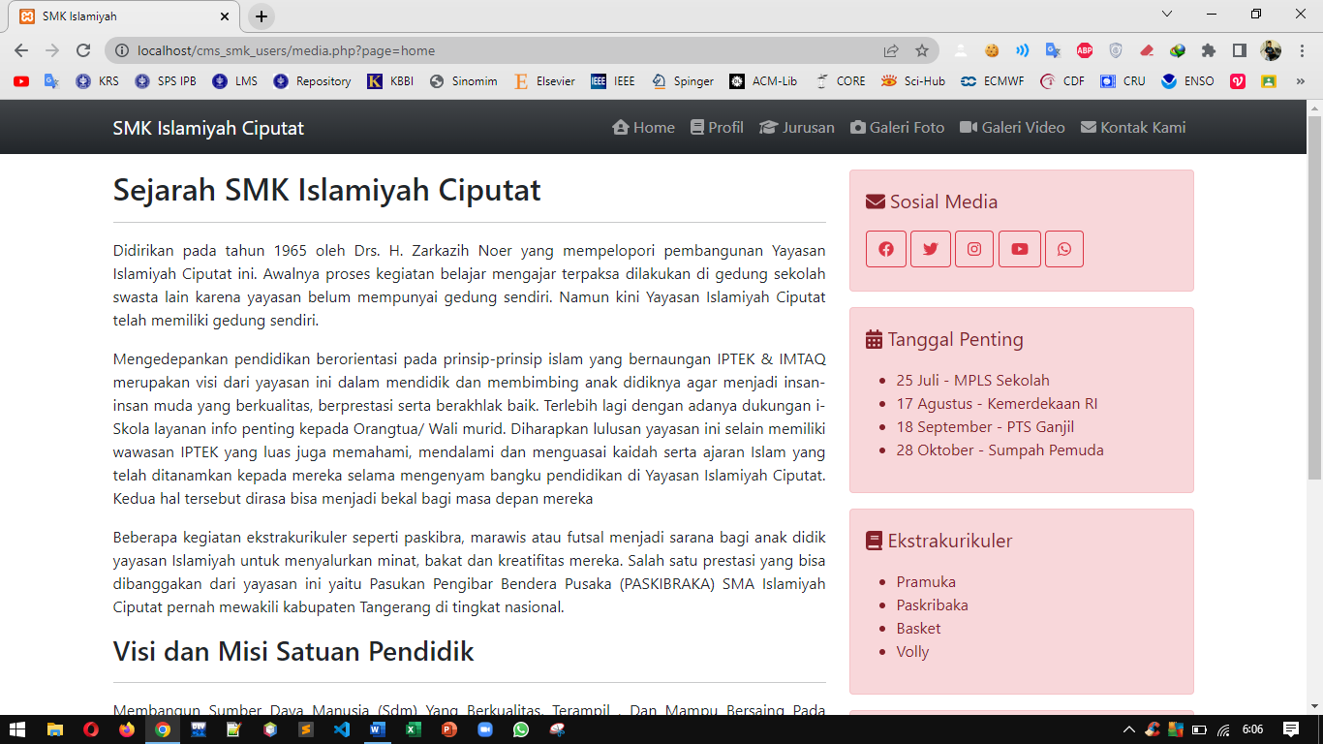

Gambar 2. home.php

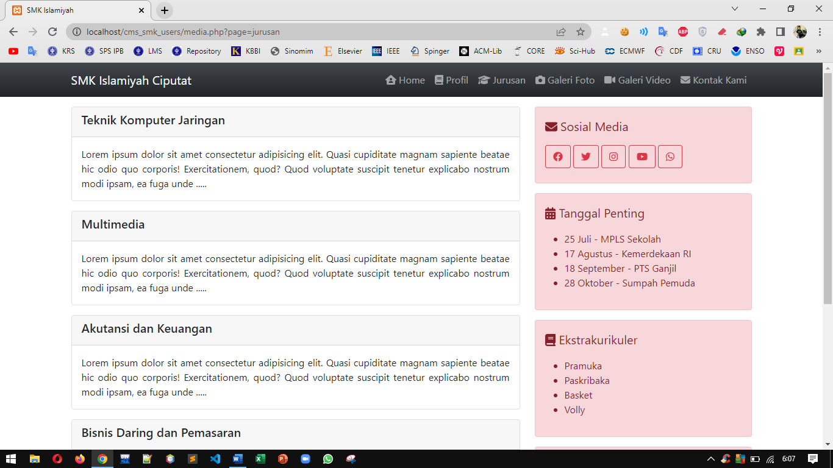

Gambar 3. jurusan.php

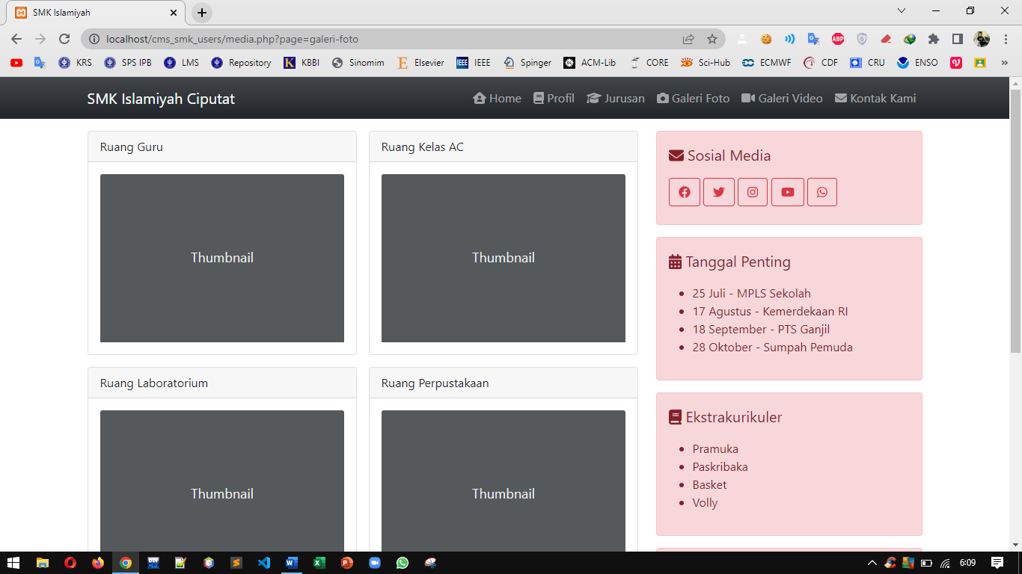

Gambar 4. galeri-foto.php

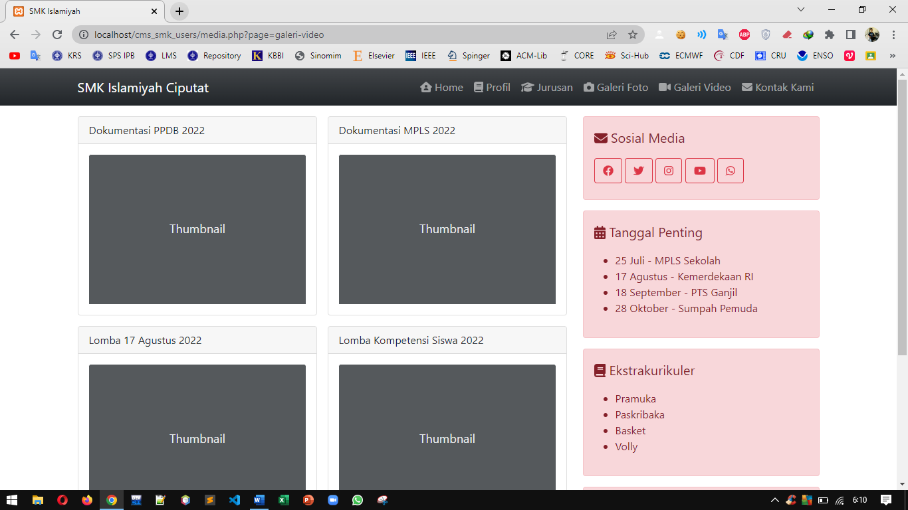

Gambar 5. galeri-video.php

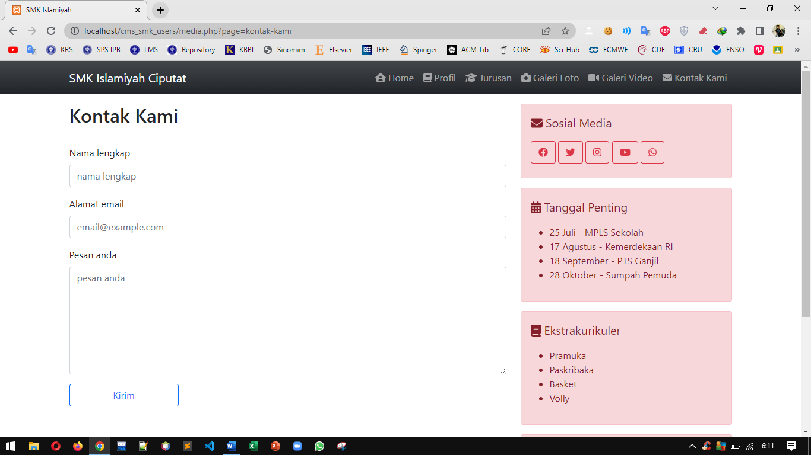

Gambar 6. kontak-kami.php